Soal
Case
Monster Book

Blitz really like Monster. So, he decided to create a book about monster, named Monster Book. Monster Book can store information about many kinds of monsters. To increase the efficiency in storing monster data in Monster Book, Blitz ask for your help as a programmer to create a program that can store monster information using C language and Chaining Hash Table data structure. The program that will be created must be following the below requirements.

- The program will have to show all monster and 4 menu items:
- Insert New Monster
- Change Monster Data
- Remove Monster
- Close Book

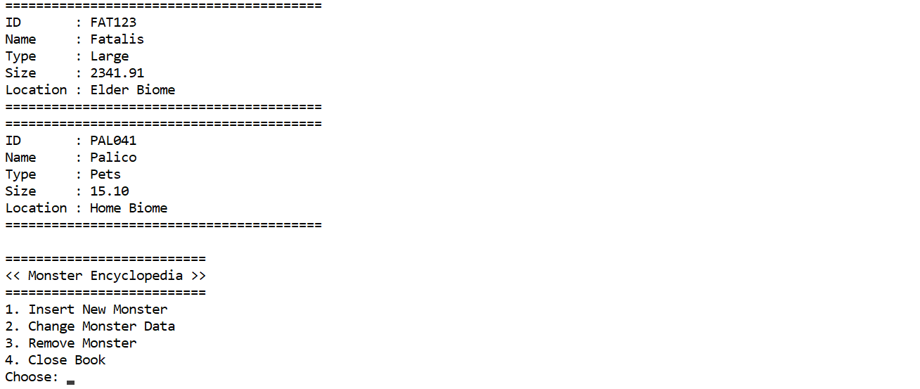
Figure 1. Main Menu

If the user choose menu 1 (Insert New Monster), then:
- The program will ask user to input the monster name and validate that the monster name must between 3 and 20 characters (inclusive) and starts with capital letter.
Figure 2. Input Monster Name

- The program will ask user to input the monster type and validate that the monster type must between “Large” or “Small” or “Endemic” or “Pets” (case sensitive) without double quote.
Figure 3. Input Monster Type

- The program will ask user to input the monster size and validate that the monster size must be in range 100 – 5000 (inclusive).
Figure 4. Input Monster Size

- The program will ask user to input the monster location and validate that the monster location must ends with ‘ Biome’ (case sensitive) without quote.
Figure 5. Input Monster Location

- The program will generate the Monster Id for the inputted monster. The Monster Id must follow the format below:
XXXYYY

XXX : the first 3 letter of the monster name and upper cased
Y : random from 0-9

Example:
Monster Name is Ion
Random YYY 385
Then the new generated Monster Id is ION385
Figure 6. Generate Monster Id

- The program will store new monster to the next monster of the last monster of chaining hash table with size 256 using the following hash function and show new monster added.
Key = SUM % Y

Key : the hash table index that will store the data
SUM : total sum of monster id ASCII
Y : size of the hash table

Example:
Monster Id : ION385
Y : 256
SUM : 390
Key : 390 % 256
: 134
Then the monster data will store at index 134 of hash table.
Figure 7. Hash Function & Push

- If the user choose menu 2 (Change Monster Data), then:
- The program will print the monster list and ask user to input the monster id that want to change.

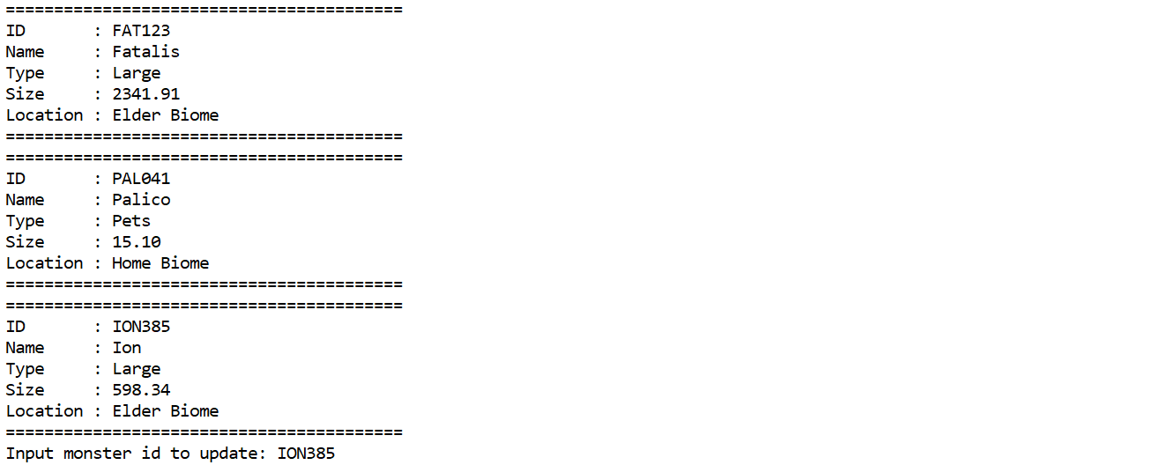
Figure 8. Change Monster Data (Input Id)

- The program will search for the specified monster.
- If the monster is not found the program will show the “Monster not found…” message
Figure 9. Monster Not Found

- If the monster exists, then:
- For each input, user can skip to update by input ‘0’ without quote.
- The program will ask user to input the monster name and validate that the monster name must between 3 and 20 characters (inclusive) and starts with capital letter.
- The program will ask user to input the monster type and validate that the monster type must between “Large” or “Small” or “Endemic” or “Pets” (case sensitive) without double quote.
- The program will ask user to input the monster size and validate that the monster size must be in range 100 – 5000 (inclusive).
- The program will ask user to input the monster location and validate that the monster location must ends with ‘ Biome’ (case sensitive) without quote.

- The program will show list of doctors and ask user to choose the doctor that will handle the patient. The following table describes the list of doctors that work in My Hospital.
- Then the program will update the monster data (if ‘0’ do not update that attribute).
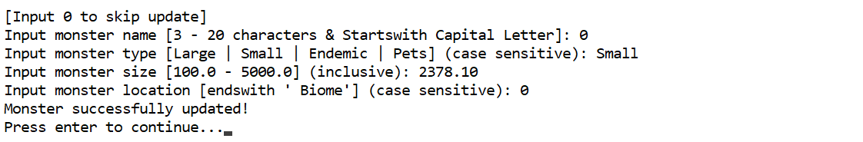

- If the user choose menu 3 (Remove Monster), then:
- The program will print the monster list and ask user to input the monster id that want to remove.
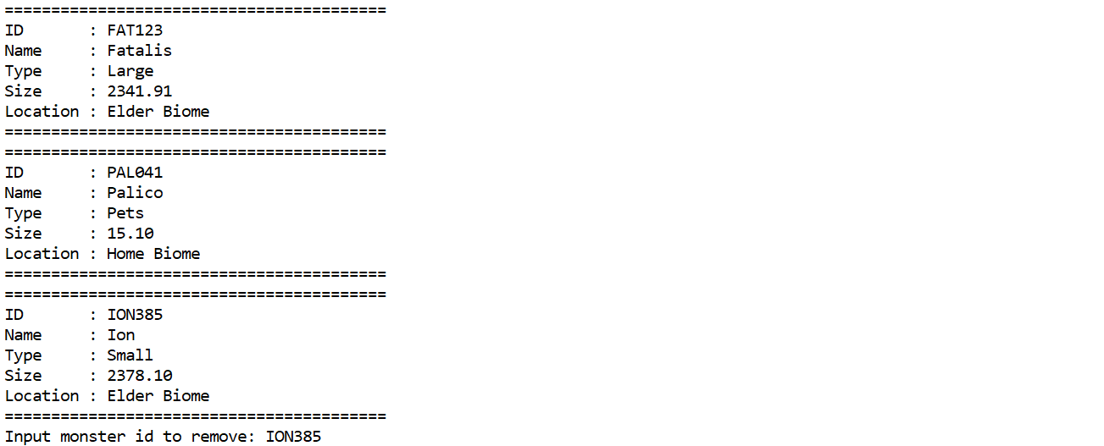
Figure 10. Remove Monster (Input Id)
- The program will search for the specified patient schedule.
- If the monster is not found the program will show the “Monster not found…” message
Figure 11. Monster Not Found

- If the monster exists, then:
  - The program will remove the monster from the chaining hash table.
  - The program will show the removed monster.
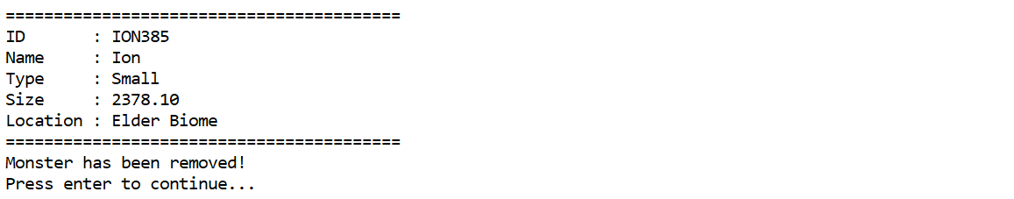
Figure 12. Show Removed Monster

- If the user choose menu 4 (Close Book), then:
- The program will show “Thank you for using monster book!” message and exit from the application.
Figure 13. Close Book

Run the exe to get more detail about the application.
Good Luck 😊

